**Welcome Letter**

Dear Carver Senior Family,

This year marks the beginning of a fresh chapter with endless possibilities. I am filled with JOY and EXCITEMENT as our seniors embark on this journey of completing high school, preparing for what lies ahead. Our vision for Carver STEAM students is to ensure students graduate LIFE ready!

As the new proud 12th Grade Dean of Students/Assistant Principal, I want us a learning community, embrace this academic year with priorities that include having *high expectations, providing high-quality instruction, and having a growth mindset.*

Senior year brings a lot of information, expectations, and fun! All information regarding dates and times of senior events, deadlines, mandatory graduation requirements, contacts, and expectations will be communicated various ways.

As we embrace this new school year, please remember that each day is a new opportunity for our students to thrive. We know that there will be many challenges, peer pressure, and days where efforts may run short. With our collective dedication we will overcome these challenges and watch our students dreams come true.

In close, I want to say welcome to Carver Steam Academy and let’s make the 2023-24 school year, a legacy year!

Let’s Go class of 2024!

Sincerely,

Dr. Rasheema Caldwell, Ed.D.

**Senior Expectations**

**ACADEMIC, BEHAVIORAL, AND ATTENDANCE EXPECTATIONS**

The final year of your high school education represents the last opportunity to learn as many skills as possible and to leave Carver Steam Academy with confidence in your ability to succeed. At Carver Steam we set the highest expectations for our senior class and encourage students to be positive role models for fellow underclassmen.

Seniors MUST BE AWARE that all senior events are a **privilege, not a right,** and come with added responsibility. Of particular importance are prom, and **all** senior field trips and activities.

Carver’s staff and administration believe academic performance (including on-track status) should be the number one priority for all seniors. Consequently, there may be eligibility requirements for some senior activities (including prom) that will be communicated at the time of the activities and students will be required to meet them. There will be no exceptions to the policies set.

Carver administration reserves the right **TO REMOVE OR BAN ANY SENIOR FROM ANY SENIOR ACTIVITY** for violation of a suspendable offense as outlined by PBSA/APS 2023-2024 Code of Conduct or for violation(s) of any other school policy while under the jurisdiction of school administration. Close attention will be paid to defiant behavior, fighting, plagiarism/cheating, attendance-related issues, document falsification, and behavior involving alcohol or any other illegal or abuse of mind-altering substances.

Finally, all seniors are expected to always maintain positive attendance. Students with skipping violations or excessive absences/tardies risk eligibility for senior activities. Moreover, seniors who have failed to adhere to service consequences assigned to them will be considered ineligible for senior activities until those obligations are fulfilled.

**CONSEQUENCES OF MAKING POOR CHOICES CAN INCLUDE ONE OR MORE OF THE FOLLOWING:**

* + INELIGIBILITY FOR UPCOMING SENIOR ACTIVITIES
  + SENIOR PRIVILEGES REMOVED
  + INELIGIBILITY/REMOVAL FROM PROM
  + REMOVAL FROM PARTICIPATION IN THE GRADUATION CEREMONY

**Outline of Senior Progressive Discipline Model:**

August-May

* + Restorative Practice support will be provided/Students will face regular consequences.
  + Consideration will be given to whether the student will be permitted to participate in the next senior activity.
  + Consideration will be given to whether the student will be permitted to participate in the remaining senior activities.
  + As mentioned earlier, student academics are highly considered prior to all student activities (including but not limited to prom).
  + All students must be on track for May graduation.

\**Students will not be sold prom tickets if they have pending consequence(s). Students who commit a violation that prohibits them from attending prom,****WILL NOT****be refunded funds for purchasing prom tickets.*

**Commencement Exercise Expectations:**

* + The student must have met ALL graduation requirements as required by the Georgia Department of Education, PBSA/APS School District
  + All community service hours must be completed.
  + Senior dues paid in full (Grad Package at minimum).
  + Any student financial obligations are paid.
  + Students **MUST PARTICIPATE**in all graduation rehearsals.
  + The student should be dressed in appropriate graduation attire as outlined by the school.
  + No Level 2 offenses or higher

*NOTE: *If a student is not eligible to walk at commencement but is eligible for graduation, the student WILL still be considered a graduate and will receive their diploma with all the rights and privileges of every other graduate.*

Please DO NOT jeopardize this once-in-a-lifetime celebration. We EXPECT exemplary behavior from all students, but even more seniors - as leaders of the school. It is not our goal to remove senior activities, but the administration will do so to uphold the dignity and standard of the Carver community.

**Senior Dues & Activities**

**SENIOR GRAD PACKAGE BREAKDOWN**

***PACKAGES ARE NON-REFUNDABLE. NO SUBSTITUTIONS.* All students are encouraged to purchase the GRAD PACKAGE to participate in the graduation Ceremony.**

|  |  |  |
| --- | --- | --- |
| **GRAD PACKAGE-$300** | **GRAD PLUS PACKAGE - $375** | **GRAD PREMIUM PACKAGE - $400** |
| Graduation  Cap and Gown  Diploma/Diploma Cover  Tassel  Kente Stole  Visions of the Future Award Ceremony | Graduation  Cap and Gown  Diploma/Diploma Cover  Tassel  Kente Stole  Visions of the Future Award Ceremony  Senior Week Activities  Senior T-Shirt/Sweatshirt | Graduation  Cap and Gown  Diploma/Diploma Cover  Tassel  Kente Stole  Visions of the Future Award Ceremony  Senior Week Activities  Senior T-Shirt/Sweatshirt  Yearbook  Lanyard |

**Students can purchase the Grad Package and add on A LA CARTE’ items below by the deadlines that will be provided.**

* Yearbook-$60.00
* Senior T-Shirt/Sweatshirt-$35.00
* Senior Parent Shirt-$25.00
* Lanyard-$10.00
* Senior Week Activities (including but not limited to: Senior Breakfast, Spirit Week, Senior Outing/Cookout, Senior Field Day)-$100.00.
* Yard Sign-$20.00
* College Tours-Rates will vary.
* Senior Trip-TBD

**PAYMENT PLAN**

|  |  |  |  |  |  |
| --- | --- | --- | --- | --- | --- |
| **Grad Package $300** | | **Grad Plus Package $375** | | **Grad Premium Package $400** | |
| September 1st | $50.00 | September 1st | $62.50 | September 1st | $67.00 |
| October 6th | $50.00 | October 6th | $62.50 | October 6th | $67.00 |
| November 3rd | $50.00 | November 3rd | $62.50 | November 3rd | $67.00 |
| December 1st | $50.00 | December 1st | $62.50 | December 1st | $67.00 |
| February 2nd | $50.00 | February 2nd | $62.50 | February 2nd | $66.00 |
| March 1st | $50.00 | March 1st | $62.50 | March 1st | $66.00 |

**How to make a payment?**

**NO CASH PAYMENTS ACCEPTED!** Dues can be paid online. Click the “Students” tab, which can be found at the top of the website. You will then see a section titled “Class of 2024 Senior Grad Dues”. Please contact Ms. Curry in the front office if you have questions about how to pay. The full amount for dues is expected to be paid by Friday, March 1, 2024. A payment plan has been created to assist with budgeting Senior Grad Dues.

**What happens if a student does purchase a Grad Package (at minimum)?**

Students will receive their diploma if earned but will not be able to participate in the Graduation or Visions of the Future Awards Ceremony because a cap and gown is required to participate in these two events.

**SNAPSHOT OF SENIOR ACTIVITIES**

|  |  |  |  |  |  |  |
| --- | --- | --- | --- | --- | --- | --- |
| **Activity** | **Homecoming** | **Senior Pictures** | **Prom** | **Senior Grad Dues** | **College Tours** | **Yearbook** |
| **Timeline** | **September** | **Dates Forthcoming** | **April/May** | **May** | **All Year** | **May** |
| **Cost** | **$250-$350**  ***\*for students who are running for homecoming court*** | **Cost Provided by Lifetouch** | **$125** | **Grad Package $300**  **Grad Plus Package $375**  **Grad Premium Package $400** | **Various Cost depending on location.** | **$60** |
| **Package Inclusive Of** | **Homecoming Attire** | **Picture Packages** | **1 Ticket Entrance and Prom Experience** | **See Details Attached** | **Tours to Colleges, including transportation.** | **1 Yearbook** |

**Senior College Tours-Optional**

*The Panthers will be hitting the road this year for our 2023-24 College Tours!* College Tours will have limited availability and is open to Caver’s Class of 2024 and 2025 (seniors & juniors).  Some tours may be multi-day tours of various colleges and universities. **The total cost associated with tours will be announced. Students must meet the registration deadline to attend.** The cost is all-inclusive, and will cover the transportation, lunch, and dinner (if applicable).

**Senior Trip-Optional: Destination TBD**

Our senior trip will be an opportunity for the seniors to have one last activity together before they graduate. Once plans for the trip are finalized, we will communicate what is specifically included, as well as the final, official price. Please keep in mind that the senior trip will be based around flights and hotel rates available at the time of planning. We will try our best to accommodate family budgets with a payment plan. We are super excited to bring this experience to our seniors.

**Community Service**

Use the QR code below to sign up for community service. Community Service projects change every two weeks. Students will be contacted and provided information on location and transportation needs prior to service date.

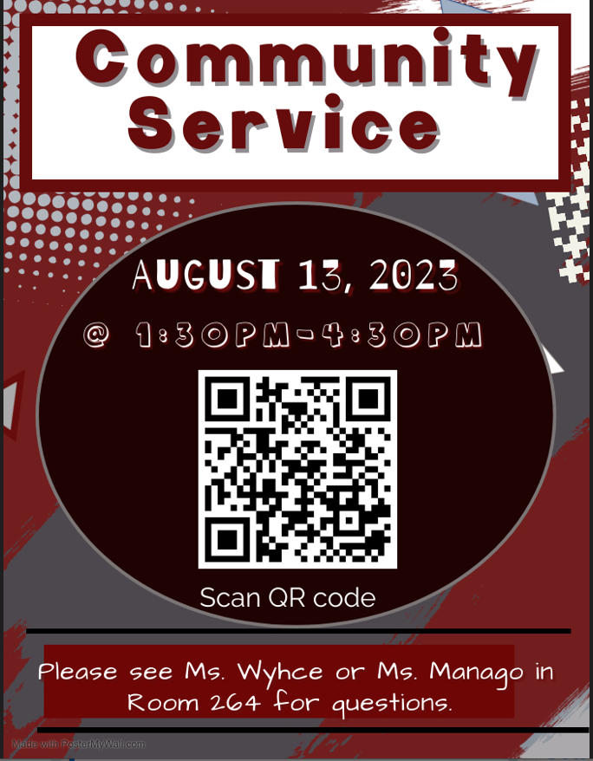

**Need a Job**



**FASA**

**What is FASA?**

The [Free Application for Federal Student Aid (FAFSA)](https://studentaid.gov/) is the form you need to fill out to get any financial aid from the federal government to help pay for college. Each year, over 13 million students who file the FAFSA get more than $120 billion in grants, work-study, and low-interest loans from the U.S. Department of Education.

Many states and colleges also use the FAFSA to determine which students get financial aid—and how much they’ll get. The FAFSA asks for information about you and your family’s finances, including tax returns, so you might need your parents’ help to complete it. If you need additional help, reach out to your school counselor.

**Who Should Fill out a FASA?**

* Anyone planning on going to college in the next academic year should fill out the FAFSA.
* Each year, millions—sometimes billions—of dollars in federal aid is left on the table by students who didn’t file a FAFSA. It’s simple: If you don’t file, you won’t qualify for most financial aid.
* Your family doesn’t have to have a low income to qualify for assistance. Even if your family makes $200,000 a year, you could be eligible for aid.
* You automatically qualify for a low-interest federal loan when you submit a FAFSA. These loans are less expensive to pay back than many private student loans.
* Many work-study programs require the FAFSA.
* Some merit-based scholarships require the FAFSA to help them determine scholarship amounts.

**How to apply for FASA?**

There are several ways to complete and submit your FAFSA:

1. Online at [studentaid.gov](https://studentaid.gov/).
2. By printing and filling out a [FAFSA form](https://studentaid.gov/sites/default/files/2022-23-fafsa.pdf), then mailing it to the address on the form.

We recommend filling out the FAFSA online. The online option offers useful tips to help you understand the questions, which can make it a lot easier to fill out and submit the application.

When you fill out the FAFSA electronically, you’ll be asked to create a federal student aid ID (FSA ID). To create your FSA ID you will need your Social Security number, full name, and date of birth. You’ll use it to sign the electronic form. Because one of your parents also must sign off on your FAFSA, they’ll need to create an FSA ID, too.

**How to create an FSA ID?**

* + Read these instructions: [Creating an FSA ID online](https://studentaid.gov/sites/default/files/creating-using-fsaid.pdf).
  + Create your FSA ID (student and parent need one): [FSA ID](https://fsaid.ed.gov/npas/index.htm)
  + Watch this video if you have any other questions: [FSA ID Video](https://www.youtube.com/watch?v=yj1Pn-shze8)

|  |  |
| --- | --- |
| fafsa logo | [Free Application for Federal Student Aid (FAFSA)](https://fafsa.ed.gov/) is your go-to site for all things financial aid. Families should utilize this site to obtain their FAFSA code and begin applying for financial aid. The application opens on October 1st. Stay tuned as College Now will be holding a financial aid workshop in which the FAFSA can be completed at John Marshall alongside knowledgeable professionals. |
|  | |
| **FASA FACTS** |  |

* Submitting the FAFSA is the most important thing you can do if you want financial aid.
* The FAFSA is free—you don’t need to pay anyone to prepare it for you.
* You need to submit a new FAFSA before each academic year in which you want to get aid. If you plan to apply for aid throughout college, you’ll need to fill out the FAFSA each year.
* Be sure to use a permanent email address on the form, not your high school email, so you can use your FAFSA account throughout college.
* The FAFSA is being simplified and redesigned in fall of 2023 to make it easier for applying for federal student aid.
* Students in the class of 2024 attending college in the fall of 2024 and other students completing the FAFSA will not be able to complete it until December 2023 instead of October when it usually opens.
* [Completing the FAFSA](https://bigfuture.collegeboard.org/pay-for-college/bigfuture-scholarships/scholarship-details/complete-the-fafsa) is just one of the six steps you can do to earn entries for [monthly scholarship drawings on BigFuture](https://bigfuture.collegeboard.org/pay-for-college/bigfuture-scholarships).

**When to Submit Your FAFSA: Understanding FAFSA Deadlines?**

If you are planning on attending college in the next academic year, you should complete the FAFSA in the fall of your senior year. Students in the class of 2024 attending college in the fall of 2024 and other students completing the FAFSA will not be able to complete it until December 2023 instead of October when it usually opens. It’s a good idea to submit the application as soon as possible because financial aid is often given out on a first-come, first-served basis.

**FAFSA Deadlines**

**College deadlines**: Important when you’re applying for aid from a college. Deadlines vary by school, so check college websites or contact the financial aid offices of the colleges you’re interested in to find out when you need to submit your FAFSA.

**State deadlines:**Important when you’re applying for aid from your state.  [Check your state's FAFSA deadline.](https://studentaid.gov/apply-for-aid/fafsa/fafsa-deadlines#state)

**Federal deadline**: June 30 is the last day you can apply for federal aid for the following academic year.

**Remember:**You should send in your FAFSA as soon as you can, regardless of deadlines. There’s a lot of financial aid out there—give yourself the best shot at getting the most assistance by applying early.

**Helpful Websites:**

College Application: <https://blog.collegeboard.org/topic/college-application>

College Planning: <https://blog.collegeboard.org/topic/college-planning>

Financial Aid: <https://blog.collegeboard.org/topic/financial-aid>

**College Tours**



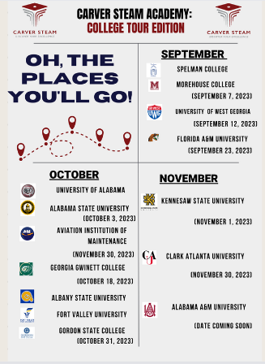

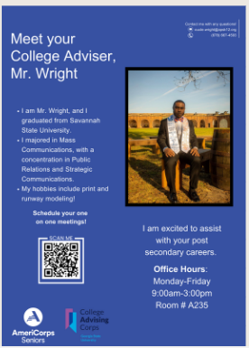

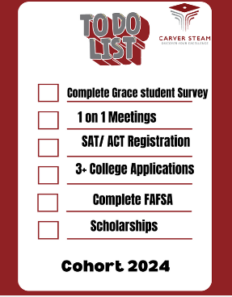

**Parent Information-Sign Up for Updates**

We will host monthly townhall meetings for students in order to remind them of important dates and upcoming events, but please join the Class of 2024 Remind to receive announcements to your phone! Text @carver2024 to 81010 to join.